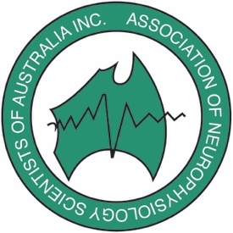
6
Association of Neurophysiology Scientists of Australia Inc.
(also known as ANSA, formerly known as ANTA)
ABN: 80 872 615 302
www.ansa.org.au

46th Annual Conference
Thursday 10th September – Friday 11th September 2026
Email: conference.ansa.au@gmail.com

August 2026
Dear Member,

As members of the 2026 ANSA Conference committee, we would like to formally invite you to attend the 46th Annual ANSA Conference to be held at Wrest Point on the banks of the Derwent River, Hobart on Thursday 10th September – Friday 11th September 2026.

Enclosed is a delegate package, containing an overview of the conference and provisional scientific program for your perusal and registration form. The Association offers the following support to those who contribute to the conference by way of presentation (formal application is required and reimbursement is provided after the conference following submission of receipt):

Two (2) ANSA members will receive reimbursement of the registration

Early Bird registration prize for two (2) ANSA members to the value of $500 each toward accommodation reimbursement (to be drawn at conference )

Webinar prize to the total value of $50 reduction in registration cost for one (1) ANSA member

Two (2) members of affiliated physiological societies may be reimbursed the cost of non-ANSA member registration – applicable when contribute by way of an oral presentation

We look forward to seeing you all in Tasmania at the 2026 Conference.

Kim Wilmot, Andrea Morley, Jayne Hulbert & Amy Waters

Conference Committee 2026
Email: conference.ansa.au@gmail.com

Delegate Information Pack

Date and Venue

The 2026 ANSA Conference is to be held from 10th – 11th September 2026.

At Wrest Point – Australian National Hotels Pty Ltd (ABN 79 009 477 552)
410 Sandy Bay Rd, Sandy Bay, Hobart, Tasmania 7005

Phone Number: (03) 6221 1857

Website: https://wrestpoint.com.au/

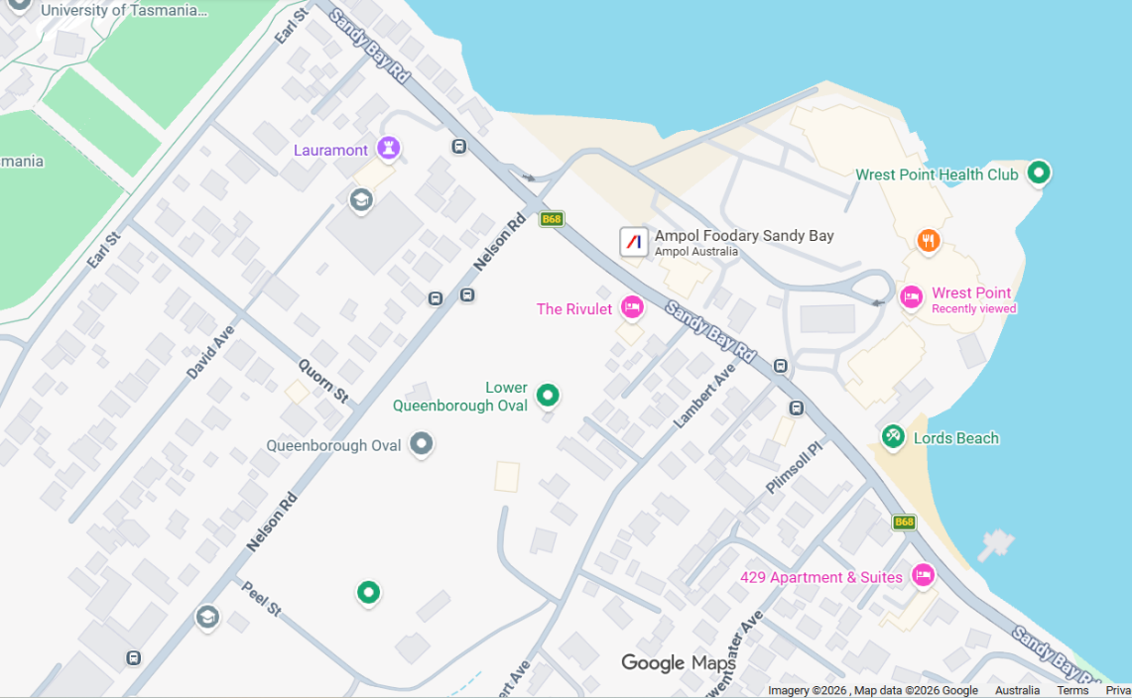

Travel from Airport:

Taxi: 20 minutes
SkyBus: 50 minutes to the wharf, then 8-minute taxi ride to Wrest Point.

Sky bus tickets: https://www.skybus.com.au/hobart-express/
Hobart bus timetable: https://www.metrotas.com.au/timetables/hobart/

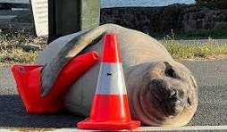
Neil the Seal, a 600kg+ southern elephant seal, has become a famous, albeit disruptive, visitor to the Hobart waterfront, and surrounding southern Tasmanian areas. He is known for "hauling out" (resting) for weeks during his moult, often choosing to lounge on roads, front lawns, and near suburban areas

Registration

A registration form for the conference is attached, send to conference email.

Please note: For early bird discount rate and to be eligible for the prize draw please register by the 30^{th of} June 2026.

Conference Organising Committee
Email: conference.ansa.au@gmail.com

Payment can be made by electronic funds transfer or direct deposit. Please use your initial and last name as your reference number so we can match up payments and registration.

Accommodation Options

Wrest Point

410 Sandy Bay Rd, Sandy Bay, Hobart, Tasmania 7005

The links are below for accommodation, 3 of the hotels have a 15% discount when pressing the links below.

Accommodation | Distance to Wrests Point | Room Details
Wrest Point | Conference | 15% discount applied via this link
Mayfair Plaza Hotel | 16 min walk
Motel 429 | 11 min walk
The Rivulet Clydesdale Mannor | 12 min walk
Grosvenor Court Apartments | 18 min walk
MACq 01 Hotel | 10 min drive | 15% discount applied via this link
The Henry Jones Art Hotel | 10 min drive | 15% discount applied via this link

Call for Abstracts – Posters & Presentations
We invite submissions for both poster and oral presentations across all areas of clinical neurophysiology. Topics may include:
- Unique or challenging clinical cases
- Current research projects
- Quality improvement initiatives
- Emerging concepts and innovations in neurophysiology
This year’s conference will also feature two interactive workshops:
- Ambulatory EEG Monitoring
- Nerve Conduction Studies
ANSA Awards will be presented for outstanding posters and presentations, including awards for Debut Presenters , Debut Posters.
We encourage clinicians, researchers, scientists, and students to submit their work and contribute to an engaging and collaborative scientific program.
If you wish to submit an abstract, please contact Andrea Morley.
Abstract submission deadline: 1 August 2026
Please note that no changes to submitted abstracts will be accepted after the submission deadline.

Email: conference.ansa.au@gmail.com

Social Events
Alongside the scientific program for the conference, social events provide an opportunity for ANSA members to mingle and network. This year, the social events will be held at:

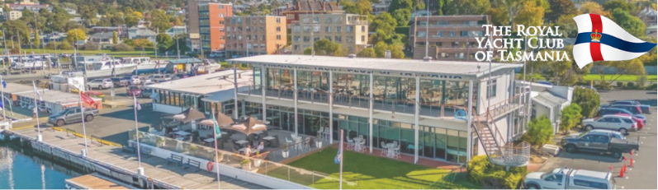

Welcome Reception
Thursday 10th September 630pm
The Royal Yacht Club of Tasmania



Awards Dinner –
Friday 11th September 630pm
Mures Upper Deck Restaurant

Stay in Touch 
During the lead up and conference to stay in touch with others or be notified of any changes/announcements - please feel free to register or sign into a Whats App if you do not have it already – To find our group: name ANSA 2026
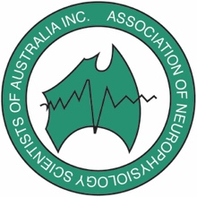

Association of Neurophysiology Scientists of Australia Inc.
ABN: 80 872 615 302
www.ansa.org.au
46th Annual Scientific Meeting 2026 Thursday 10th September – Friday 11th September

Association of Neurophysiology Scientists of Australia Inc.
ABN: 80 872 615 302
www.ansa.org.au
46th Annual Scientific Meeting 2026 Thursday 10th September – Friday 11th September

INVOICE
Invoice Number: office use only

Delegate Information
Surname: |  | First name: |  |  |  | Mr  Mrs  Dr  Miss  Ms | Telephone:
Organisation: |  |  |  |  |  | Mr  Mrs  Dr  Miss  Ms | Email:
Address:

Confirm dietary requirements: Please confirm

Full Registration : Circle option required
 |  |  |  |  |  |  |  | ANSA
 |  |  |  |  |  |  |  | MEMBER | NON-MEMBER
All sessions, morning and afternoon teas, lunches, Welcome Reception and Conference Dinner. | Early Bird CLOSED (Until 30th June 26) |  |  |  |  |  |  | $500 | $650
 | Registration (After 1st July 26) |  |  |  |  |  |  | $700 | $850

Day Registration
Plenary sessions on selected day, morning and afternoon tea, and lunch. |  |  | Thursday 10th Sept |  |  |  |  | $250 | $325
 |  |  | Friday 11th Sept |  |  |  |  | $250 | $325
Online Registration (Virtual Attendance of Presentations) |  |  | Thursday & Friday |  |  |  |  | $200 | $250
 |  |  | One Day only |  |  |  |  | $110 | $135
OPT OUT: Welcome Reception (10th Sept @ 6.30pm) Conference Dinner (11th Sept @ 6.30pm)

Additional dinner guest: Welcome Drinks: $100 Conference Dinner : $150

PAYMENT – Please include your surname in the reference
*Please note: No cash payments will be accepted
Account Name: Association of Neurophysiology Scientists of Australia Inc  BSB: 036 011 ACCOUNT NO: 413526  International SWIFT Code: WPACAU2S  Ref: please include your surname in the reference  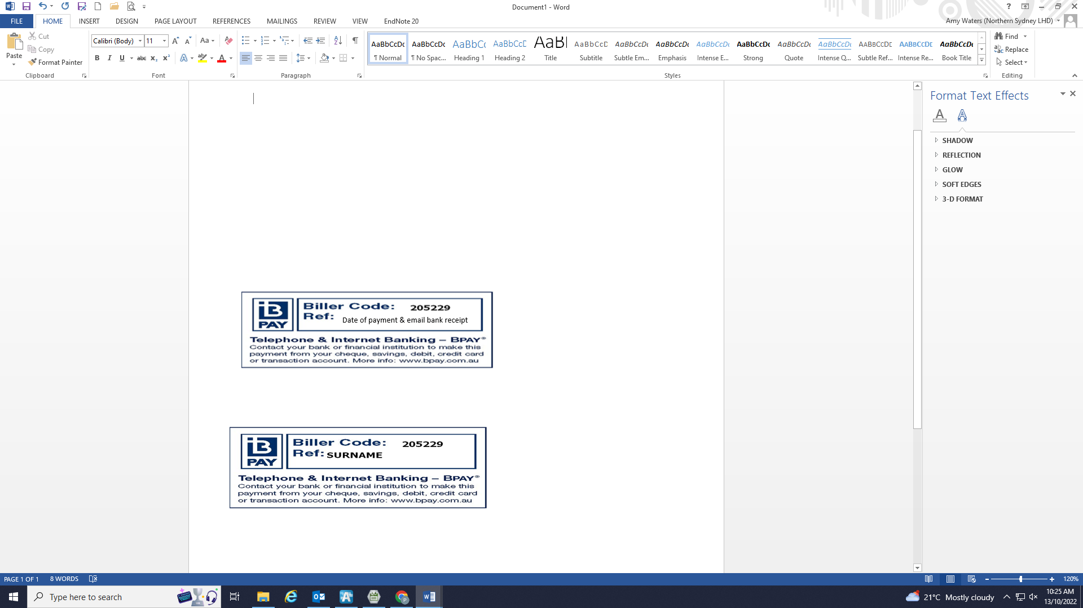 |  |  |  |  | Please send remittance for EFT to:  ANSA Treasurer: treasurer.ansa.au@gmail.com  &  Conference Organisers: conference.ansa.au@gmail.com

Payment Date:
Total $ __________

ANSA INC photo PERMISSION: The Association would like to post photos in the Members section of the website and Conference photo albums. The Members only section can only be accessed by current financial members. These photos will be in accordance with the Privacy (Private Sector) Regulations Act 2001.

Please notify organising committee if you would not like your photos published.

